Online Travel Reservation System

**Team Members:**

ID Name Dept./Group

**20130352 Mohammed Ali Shabanah IS/4**

**20130356 Hameed Muneef IS/4**

**20130359 Ahmed Fathi IS/4**

**20130355 Shimaa**  **AbduAlkader IS/4**

**20130357 Mohammed Ahmed IS/4**

Presented to: **TA.Fatma and TA.Aliaa**

**Date:**30th Nov. 2015

**WBS**

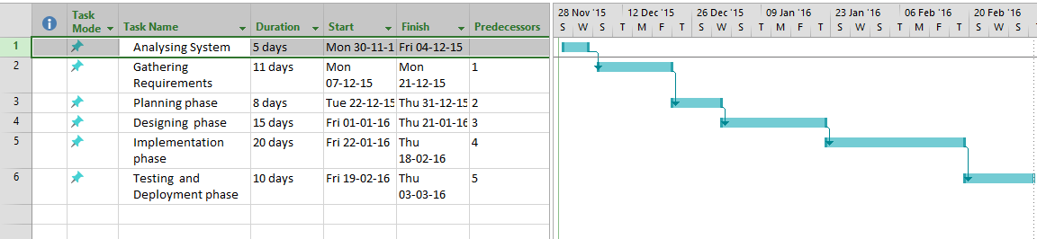 **Gantt-Chart**

** Time –Line**

**Mile-Stones**

|  |  |
| --- | --- |
| **Task** | **Mile-Stone** |
| **Analysis phase** | System is understood and studied |
| **Requirements gathering phase** | Covering stack-holders requirements and preparing system to be designed |
| **Design phase** | System is Modeled |
| **Implementation phase** | System is Written into programming language to perform it is functionality |
| **Testing and deploying system phase** | Testing the results of the system developed and deploy them to work |

**2.stuff Resources**

|  |  |  |  |
| --- | --- | --- | --- |
| Name | Title | Email | phone |
| **Ahmed Fathi Rashad** | **Project Sponsor & Quality Specialist** | **ahmed.goldenboy19@gmail.com** | **01112920268** |
| **Mohammed Ali Shabanah** | **Project manager && Testing specialist** | **shabanah825@hotmail.com** | **01021665562** |
| **Shimaa Abdulkader Mohammed** | ***Technical Writing && St. Quality specialist*** | ***azharstar977@yahoo.com*** | **01111280879** |
| **Hameed Hussein Yehia** | **System analyst && senior Programmer** | [**hameedmuneef2014@gmail.com**](mailto:hameedmuneef2014@gmail.com) | **01150635538** |
| **Mohammed Ahmed Mohammed** | **Programmer && Quality Specialist** | **m.alsadeha@gmail.com** | **01093656567** |

**3-RACI**

|  |  |  |  |  |  |  |
| --- | --- | --- | --- | --- | --- | --- |
| **Tasks** | **Project manager** | **System analyst** | **Project sponsor** | **Senior programmer** | **Quality specialist** | **Testing specialist** |
| **Analyzing** | **I,C** | **A** | **I** |  |  |  |
| **Gathering requirements** | **I,C** | **A** | **I** | **I** | **I** |  |
| **Planning** | **A** | **I,C** | **I** |  |  |  |
| **Designing** | **I,C** | **I,C** | **I** | **A** | **I,C** | **I** |
| **Implementation** | **I** | **I** | **I** | **A** | **I,C** | **I** |
| **Testing** | **I,C** | **I** | **I** | **I,C** | **I,C** | **A** |